The 5th Young Researchers' Quantitative Symposium (YRQS) 2025
7 January 2025, Sintok, Kedah, Malaysia

Internal Migration Trend and Factors in Malaysia

Ziqing Ge^{*a}, Suzilah Ismailª

ªSchool of Quantitative Sciences, Universiti Utara Malaysia UUM Sintok, Kedah, Malaysia

Abstract

Internal migration is essential for urbanization and population redistribution. However, unequal interstate migration in Malaysia causes labour shortages in the origin region (outflow) and overcrowding issues in the destination region (inflow). Understanding internal migration is essential to manage the population flow properly. Therefore, this study investigated the internal migration trend by considering the global crisis and related factors, including relative poverty, median household income, Gini coefficient index, unemployment rate, population density, and Gross Domestic Product (GDP) in Malaysia 2007-2022. The data was obtained from the Department of Statistics Malaysia (DOSM). Exploratory Data Analysis (EDA) and ArcGIS mapping techniques were applied to investigate the internal migration trend. Correlation and Multiple Linear Regression were used to identify the factors related to internal migration. The findings indicated that Selangor and Johor, which commonly receive the migration flow (inflow), experienced significant increasing net migration outflow during the global crisis. In contrast, Pahang and Perak, which regularly send migrants to other states, experienced significant increasing net migration inflow. This is because many people are unemployed during global crises and must return to their hometowns to survive. The factors that showed a significant relationship with net internal migration are relative poverty, median household income, unemployment rate, Gini coefficient index, and GDP. The government should establish development policies by providing more job opportunities in outflow states and enhancing infrastructure like transportation and housing in inflow states to manage migration effectively. Unemployment benefits and financial aid should also be given during the global crisis to prevent large-scale migration.

Keywords: Internal migration trend, net migration rate, economy

INTRODUCTION
Internal migration refers to human mobility within a country and has significantly resulted in population redistribution (Charles-Edwards et al., 2019) and urbanization (Geyer & Kontuly, 1993). However, the migration flow among the states of Malaysia is unequal according to the Department of Statistics Malaysia (DOSM, 2023) which many people migrated to W.P. Putrajaya, Selangor, and Johor with the number of 6700 people, 7900 people, and 11900 people respectively. Meanwhile, many people went out from W.P. Kuala Lumpur and Pahang with the numbers of 16100 and 8100, respectively. A large-scale migration inflow and outflow will bring disadvantages. From the perspective of migrants' destinations, which refer to the regions that receive the population, large-scale population inflow may create a tense atmosphere in society. From the perspective of migrants' origin, which refers to the region that sends the population, it will experience a labour shortage. The outgoing workforce will slow down the economic development of an area and cause an imbalance in the growth of the area.
Neoclassical economics, pioneered by Harris and Todaro in 1970, is the first theoretical framework to explain labour migration. Income differential and working opportunities are the priority reasons for migration. Abdul Wahab et al. (2020) stated that high-skilled graduates will migrate to obtain higher-paid jobs. Hussain et al., (2018) and Danial (2019) suggested a significant relationship between the net internal migration and the socioeconomic factors such as poverty rate, unemployment rate, demographic factors, and so on in the developed state of Malaysia. However, recent articles regarding internal migration in Malaysia have mostly focused on certain areas such as the Selangor and Klang areas. Besides, Fielding and Ishikawa (2021) showed that the COVID-19 pandemic had a significant impact on the internal migration trend, which has limited study in Malaysia. Therefore, this study investigates the internal migration trend according to demographic characteristics (e.g., gender and age) and states. The factors related to internal migration include relative poverty, median household income, Gini coefficient, unemployment rate, population density, and Gross Domestic Product (GDP), which have also been explored. This study examined the internal migration trend according to gender and age of internal migrants from 2007-2022, to compare the net internal migration rate by state from 2007-2022, and to identify the factors that relate to the net internal migration rate by state from 2007-2022.

METHODS
This study was implemented using secondary data from DOSM. Exploratory data analysis has been applied to investigate the internal migration trend according to gender and age of internal migrants from 2007-2022. The internal migration rate was used with the formula of
$${Internal migration rate}_{i}=\frac{m_{i}}{P_{i}}x100\%$$
where 𝑚𝑖 refers to total internal migrants while 𝑃𝑖 refers to the population per 1000 with specific characteristics. Line chart and ArcGIS mapping were used to compare the net internal migration by state from 2007-2022. The formula used was as follows:
$${Net internal migration rate}_{i}=\frac{I_{i}-O_{i}}{P_{i}}$$
where 𝑂𝑖 is the number of out-migrants from the origin area i; 𝐼𝑖 is the number of in-migrants to the destination area i; and 𝑃𝑖 is the population per 1000.
Correlation and Multiple Linear Regression Model were used to identify the factors related to the net internal migration in Malaysia from 2007-2022. The formula of regression was written as
$y_{t}$ = $β_{0}$ + $β_{1}x_{1,t}$ + $β_{2}x_{2,t}$ + $β_{3}x_{3,t}$+ $β_{4}x_{4,t}$+ $β_{5}x_{5,t}$+ $β_{6}x_{6,t}$+ $£_{i}$
where $y_{t}$=net migration rate, $x_{1}$=relative poverty, $x_{2}$=household income median, $x_{3}$=Gini coefficient index, $x_{4}$=unemployment rate, $x_{5}$=population density, $x_{6}$=gross domestic product.
Microsoft Excel, SPSS, and ArcGIS mapping software have been used in the data analysis.

RESULT AND DISCUSSION
3.1 THE INTERNAL MIGRATION TREND
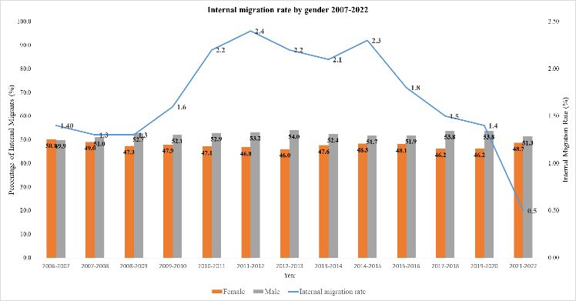 | 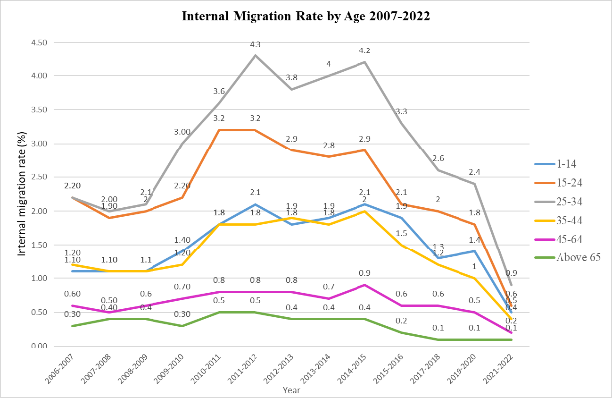
Figure 1: Internal migration rate by gender and age from 2007-2022

Figure 1 shows that the internal migration rate decreased from 1.4% in 2006-2007 to 1.3% in 2007-2008 and 2008-2009. According to DOSM (2023), the decrease in the number of migrants from 2007-2008 to 2008-2009 was due to the sub-prime crisis in the United States (US) 2008 and the Euro-Zone turmoil in Europe at the end of 2009. The global crisis caused a global financial meltdown and directly affected businesses and economies in Malaysia by reducing foreign investment and exports. Retrenchments, voluntary separations, temporary layoffs, and salary cuts impacted tens of thousands of workers at that time (DOSM, 2009). These events cause limited job opportunities and financial incentives for migration. The internal migration increased from 1.3% in 2008-2009 to 2.4% in 2011-2012, showing a recovery trend from the economic crisis. After reaching a peak of 2.3% in 2014-2015, the migration trend gradually decreased to 1.4% in 2020. Shuttleworth and Champion (2021) surprisingly found a decreasing level of spatial mobility, especially for internal migrants with higher incomes and economic development. Economic development will ensure a more equitable distribution of resources and opportunities across states, reducing migration incentives. The economic slowdown enhanced the decreasing trend. The net internal migration rate plummeted to 0.5 in 2022 due to Covid 19. People may have avoided moving and appreciated the time spent with family after experiencing the pandemic. The numbers for both genders generally followed the same trend, with male migrants consistently slightly higher than females, with the highest differences of 7.9% in 2012-2013 except in 2006-2007 which females were 0.2% higher than males. This may be due to the traditional gender roles and employment patterns. As the breadwinners, men often move for better job opportunities and quality of life. Meanwhile, females are more tied to their families, influencing their migration decisions. The differences in the number of male and female migrants in Malaysia have been reduced since 2000 (Abdul Rashid et al., 2023), possibly due to the increasing percentage of females in labour force.
Figure 1 shows that the age group 25-34 has the highest migration rate among all age groups and mostly migrates for working purposes. The age group 15-24 has the second highest migration rate, and most students are enrolled in higher learning institutions. The age group 1-14, which usually migrates with parents or guardians, showed similar internal migration patterns to those of the age group 35-44. The age group 45-64 and above 65 has a low internal migration rate of below 1%. Older people usually are less likely to move due to homeownership and network connections in their original hometown.
3.2 COMPARISON OF NET INTERNAL MIGRATION RATE BY STATE
Table 1 shows that W.P. Kuala Lumpur, Pahang, Perak, and Perlis always experienced net internal migration outflow in the recent 5 year. In contrast, Selangor, Pulau Pinang, Johor, Melaka, Negeri Sembilan, and Kelantan have experienced net internal migration inflow in the recent 5 years. Meanwhile, Kedah, Terengganu, Sabah and Sarawak showed approximately zero net internal migration in the recent 5 years. However, Perlis was going upward while Pulau Pinang was on a downward trend, which showed that they are likely to switch roles in the future. The migration flow changed when the global crisis happened.
Table 1. Net Internal Migration Rate by State from 2007-2022
Significant Net Internal Migration Outflow  (Recent 5 years) | W.P. Kuala Lumpur  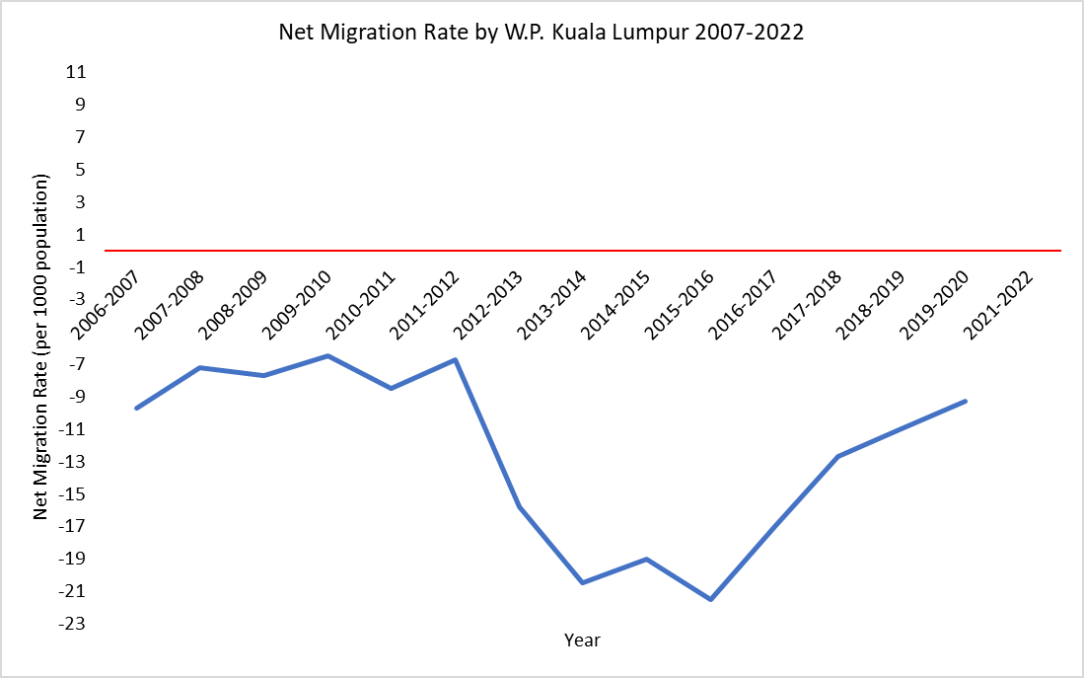 | Pahang  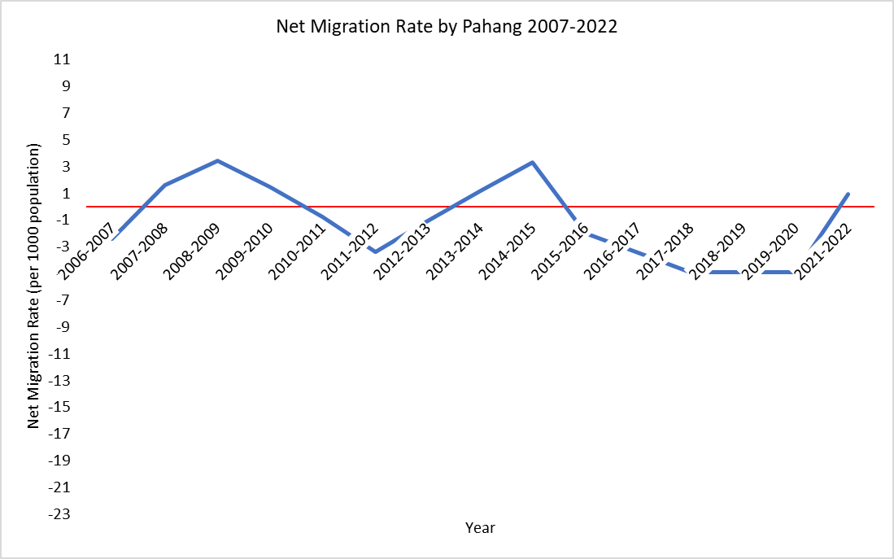 | Perak  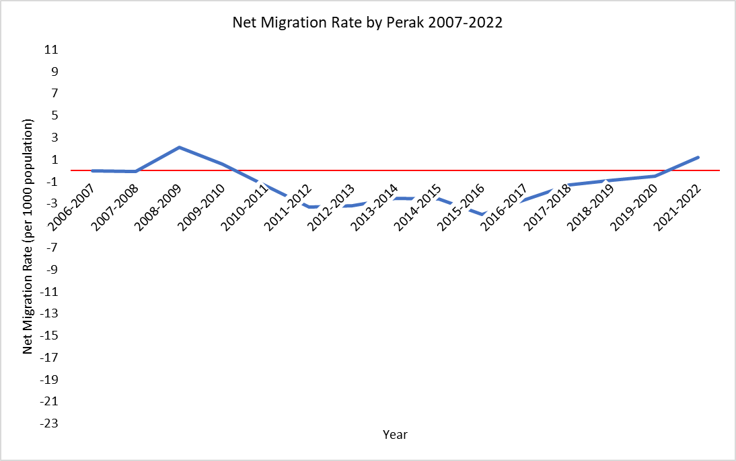 | Perlis  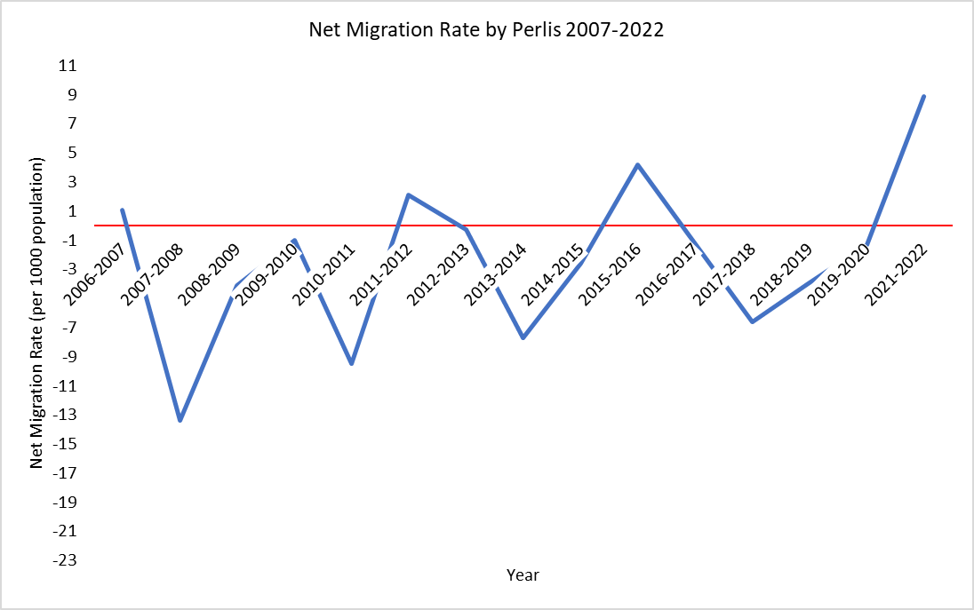
Approximately Zero Net Internal Migration  (Recent 5 years) | Kedah  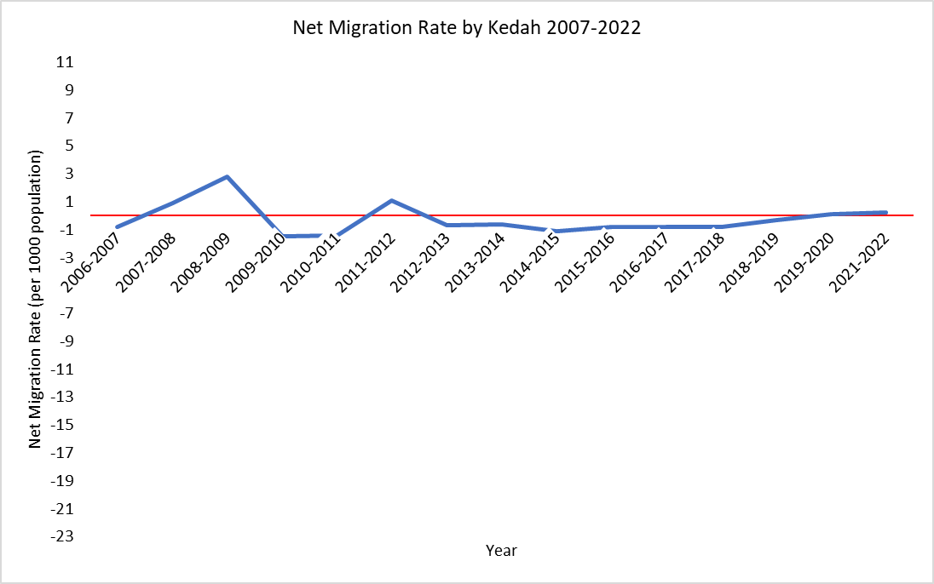 | Terengganu  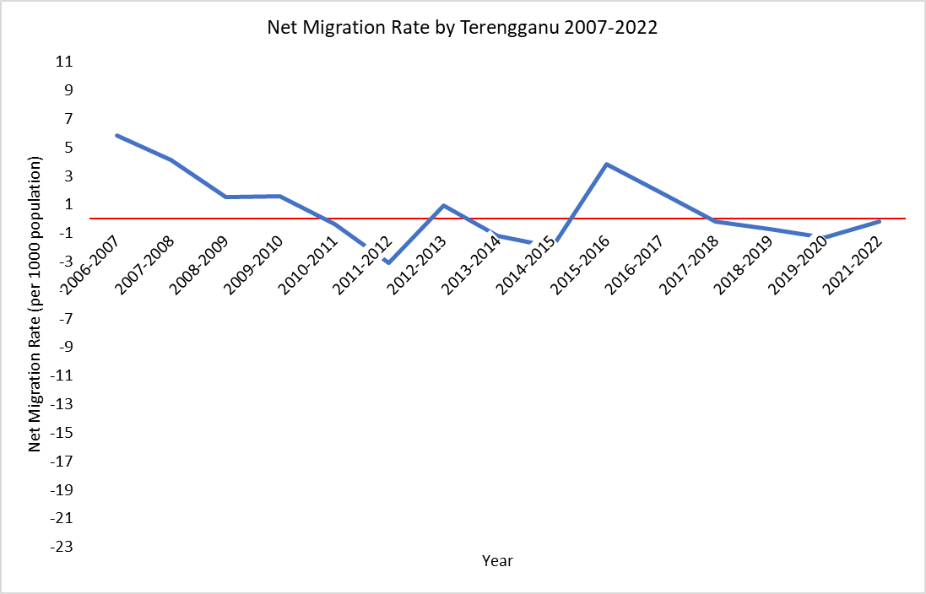 | Sabah  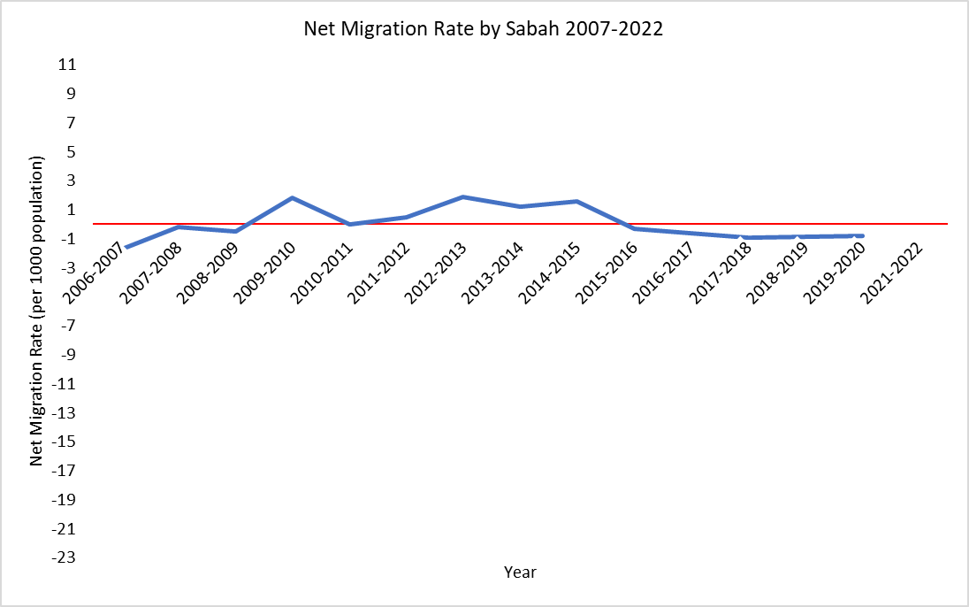 | Sarawak  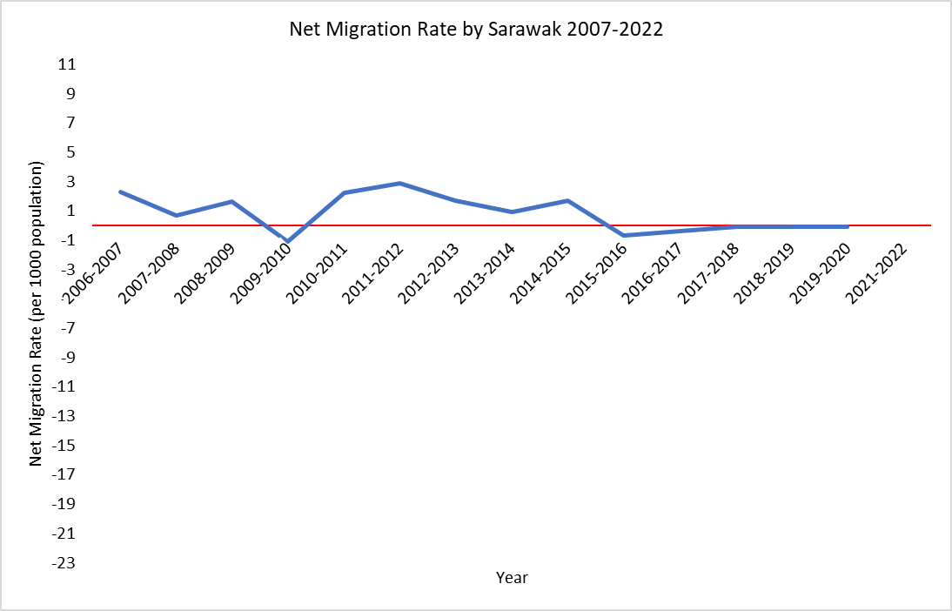
Significant Net Internal Migration Inflow  (Recent 5 years) | Johor  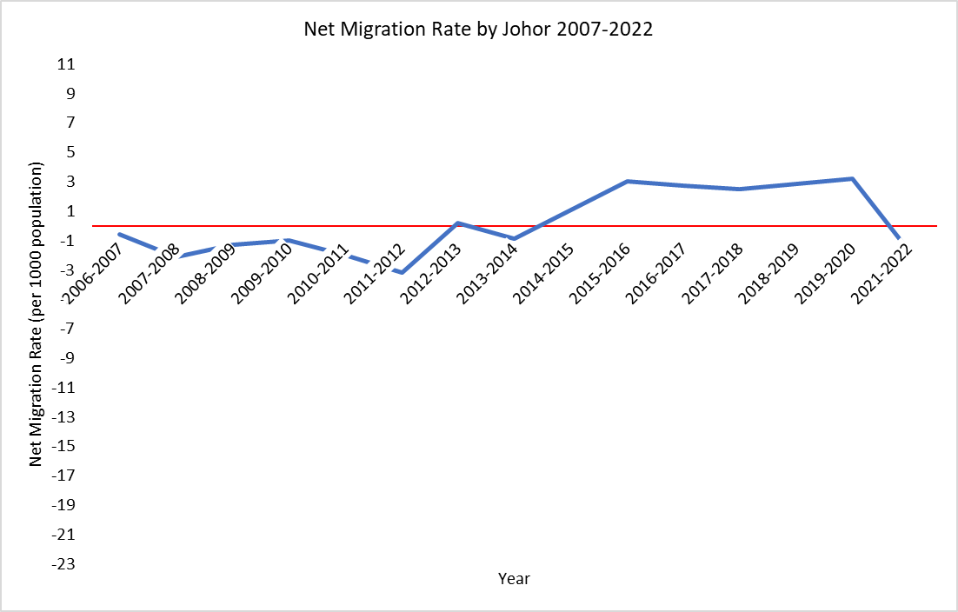 | Kelantan  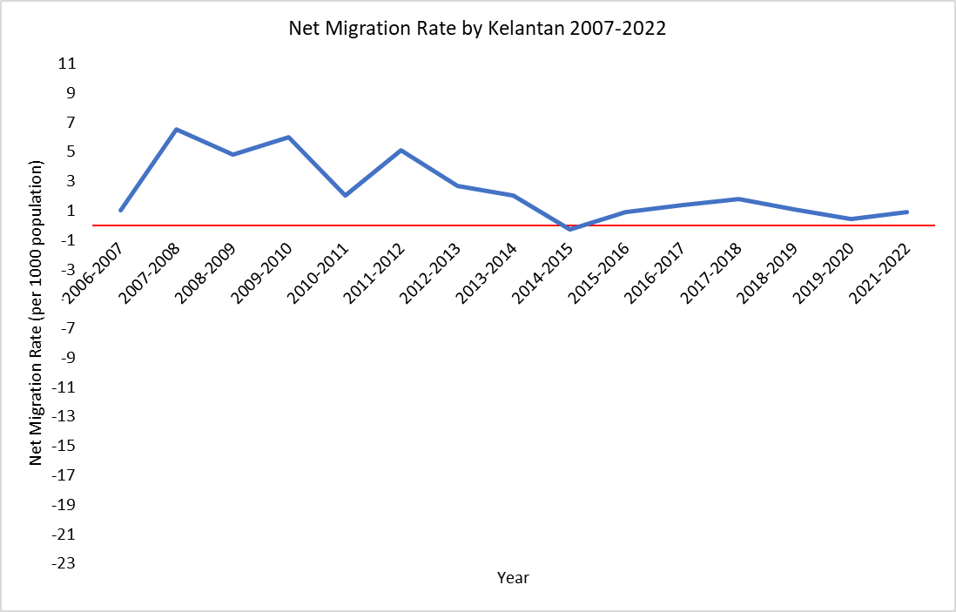 | Melaka  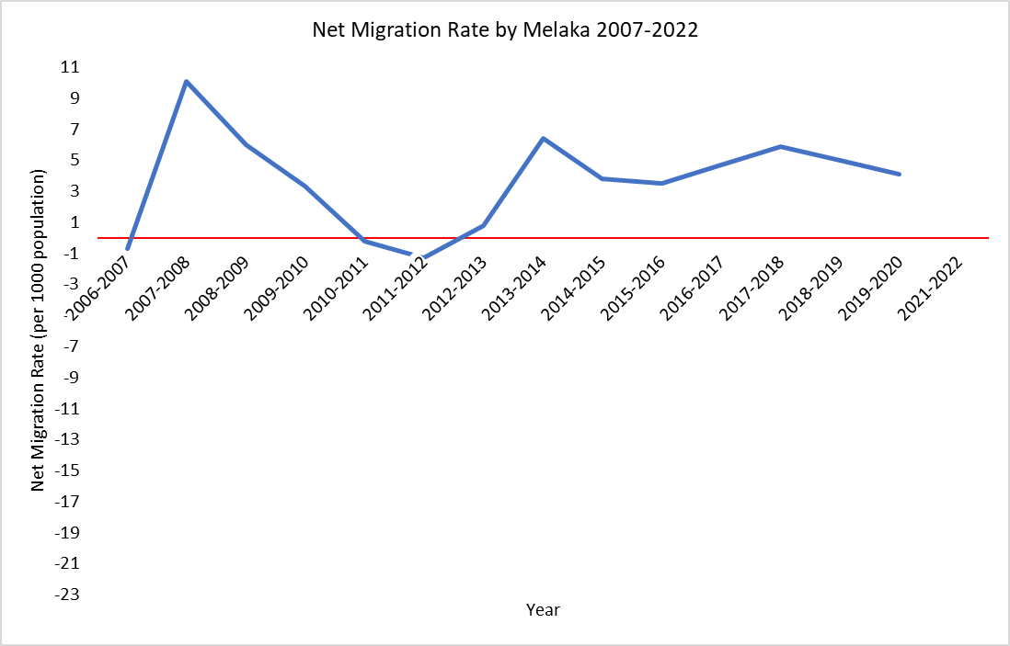 | Negeri Sembilan  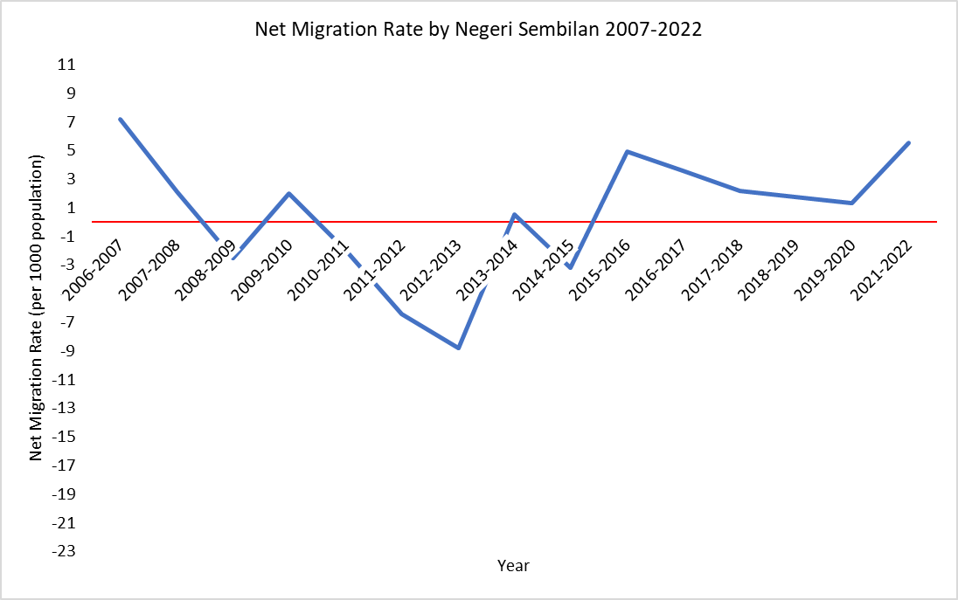
 | Pulau Pinang  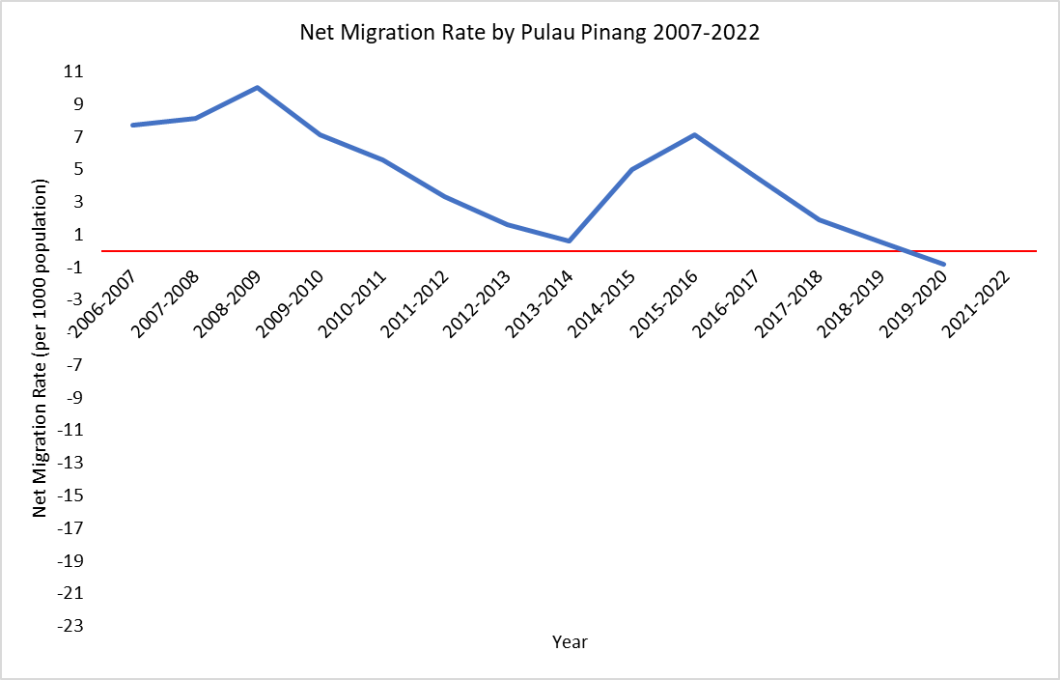 | Selangor  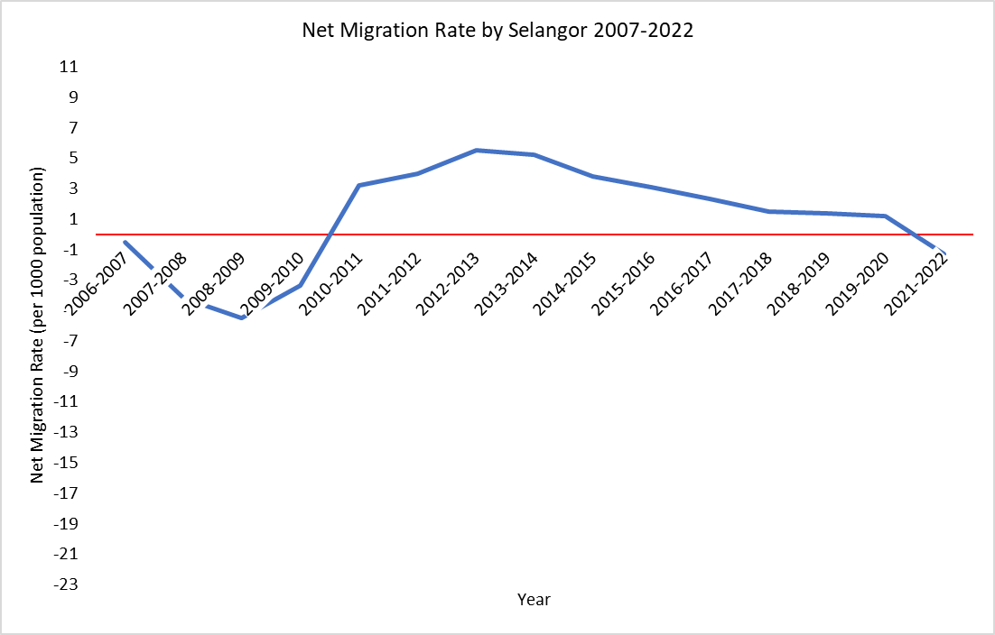
Figure 2 shows that Johor, Perlis, Sarawak, and Selangor experienced an increasing significant net migration outflow while Pahang, Sabah, Perak, Kelantan, and Melaka experienced significant increasing net migration inflow in 2009-2010. However, under normal circumstances, the internal migration pattern reverses. This is because people tend to move from states with high living costs to states with low living costs due to the economic crisis in 2008 and 2009. Meanwhile, Negeri Sembilan, Terengganu, Kelantan, and Pulau Pinang continuously experienced net migration inflow, while W.P. Kuala Lumpur, Selangor, Johor, and Kedah continuously experienced net migration outflow in 2006-2007 and 2009-2010.
Figure 2 shows that under the impact of COVID-19 pandemic, Johor and Selangor experienced a significant increasing net migration outflow, while Pahang, Perlis, and Perak experienced a significant increasing net migration inflow in 2021-2022. However, under normal circumstances, the internal migration pattern reverses. This is because the population tends to migrate from places with high population density to places with low population density to avoid infection. At the same time, Negeri Sembilan, Kelantan, and Kedah continuously experienced net migration inflow in 2019-2020 and 2021-2022.
Figure 2: Mapping of net migration rate by state from 2007-2022
3.3 FACTORS RELATED TO THE NET INTERNAL MIGRATION RATE BY STATE
Based on Pearson and Spearman Correlations, significant factors related to internal migration are median household income, unemployment rate, Gini coefficient index, and GDP based on several states. As shown in Table 2, the regression results also indicated similar factors which are relative poverty, median household income, unemployment rate, Gini coefficient index, and GDP.
Table 2. Multiple Linear Regression Result by State
 | Intercept | Relative poverty  ($x_{1}$) | Gini coefficient  ($x_{2}$) | Median household income  ($x_{3}$) | Unemployment rate  ($x_{4}$) | Population density  ($x_{5}$) | GDP  ($x_{6}$) | Adj. R square | Assumption
Kedah | -4.136**  .011 | - | - |  | 1.238**  .015 | - | - | 0.329 | Fulfill
 | Explanation: In Kedah, every 1 unit increase in the unemployment rate leads to 1.238 more people migrating to Kedah. This suggests that people move to Kedah during economic downturns.
Perak | 62.072***  <.001 | (ln)  -8.792***  <.001 | - | (ln)  -5.004***  <.001 | - | - | - | 0.820 | Fulfill
 | Explanation: In Perak, every 1% increase in the relative poverty rate and median household income will cause a decrease in the net internal migration rate by 8.792 and 5.004 people respectively. Guriev and Vakulenko (2015) stated that higher incomes in rich regions result in lower net migration outflows, but an increase in incomes in the poorest regions will result in higher migration outflow. The rise in income may not be enough to retain them in Perak, but it increases their financial ability to move to another region.
Selangor | -91.316***  0.008 | (ln)  10.214**  .066 | (ln)  -80.663***  <.001 | - | (ln)  -8.912***  <.001 | - | - | 0.858 | Fulfill
 | Explanation: In Selangor, a 1% increase in relative poverty rate increased the net internal migration by 10.214 people as they cannot afford the cost of leaving cause less people move out. However, every 1% increase in Gini coefficient index and unemployment rate reduced net internal migration by 80.663 and 8.912 people respectively as people tend to move to places with low living costs during economic instability.
Terengganu | -31.893***  0.003 | - | (reciprocal)  8.908***  .005 | (reciprocal)  27302.310***  <.001 | - | - | - | 0.603 | Fulfill
 | Explanation: In Terengganu, Gini coefficient (+8.908) and median household income (+27302.310) show an inverse relationship with the net internal migration. As these factors increase, the net migration decreases at a gradually smaller rate as the values increase.
W.P. Kuala Lumpur | -533.731***  <.001 | - | - | (ln)  -95.750***  <.001 | - | - | (ln)  115.018***  <.001 | 0.866 | Fulfill
 | Explanation: In W.P. Kuala Lumpur, 1% increase in median household income reduces net internal migration rate by 95.750 people, while every 1% increase in GDP increases net internal migration by 115.018 people. High-income areas have high living costs (Renas & Kumar, 1978). Even though the household income median increased, people tend to move out from the W.P. Kuala Lumpur due to high living cost.
Significance levels are denoted as *** for 1% (p < 0.01), ** for 5% (p < 0.05), and * for 10% (p < 0.10).

CONCLUSION
Internal migration contributes to urbanization and development but brings challenges such as labor shortages in origin areas and destination overcrowding. It is essential to understand the internal migration trend and its related factors. The percentage of male migrants was consistently slightly higher than that of females, with the highest differences being 7.9% in 2012-2013, except in 2006-2007, when females were 0.2% higher than males. The age group 25-34 has the highest migration rate among all age groups for working purposes.
W.P. Kuala Lumpur, Perak, Pahang, and Perlis experienced net internal migration outflow while Selangor, Pulau Pinang, Johor, Melaka, Negeri Sembilan, and Kelantan experienced net internal migration inflow in the last 5 years. However, Perlis demonstrated an upward trend, while Pulau Pinang showed a downward trend, which showed the potential for role reversals in the future. The global crisis also significantly influenced inter-state migration as people tend to move to places with low living costs and low population density because many people are unemployed and must return to their hometowns to survive. During the global crisis, Selangor and Johor experienced a significant increasing net migration outflow, while Pahang, Perak experienced significant increasing net migration inflow. However, under normal circumstances, the internal migration pattern reverses.
Relative poverty, median household income, unemployment rate, Gini coefficient index, and GDP are frequently related to each state's net internal migration. The differences in migration trend and factors underlines the need for region-specific policies to ensure balanced development and mitigate the adverse effects of migration on both origin and destination areas. States like Pahang, and Perak continuously experienced net migration outflow due to a lack of job opportunities. The government should offer incentives and develop transportation infrastructure to attract companies to less urbanized areas to create more job opportunities. The government should also plan to accommodate the increasing population density in certain states such as Selangor, Johor, Negeri Sembilan and so on by investing in low-price housing, public transportation, healthcare, and education to ensure sustainable development. During the global economic crisis, providing unemployment benefits and financial aid prevents large-scale migration inflow or outflow to a specific state.

REFERENCES
Abdul Rashid, S., Saadan, N., & Mokhtar, M. (2023). Internal migration trends in Malaysia. International Journal of Accounting, Finance and Business (IJAFB),8(49), 267-278.
Abdul Wahab, D., Tey, N. P., & Jani, R. (2020). Interregional migration and graduate earning in Malaysia. Institutions and Economies, 12(2), 107-128.
Charles-Edwards, E., Bell, M., Bernard, A., & Zhu, Y. (2019). Internal migration in the countries of Asia: levels, ages, and spatial impacts. Asian Population Studies, 15(2), 150–171. https://doi.org/10.1080/17441730.2019.1619256
Danial, M. H. B. (2019). Population growth, internal migration and urbanisation in Malaysia: Recent and future trends, 1980–2040 (Doctoral dissertation, University of Liverpool). University of Liverpool. https://doi.org/10.17638/03071027
Department of Statistics Malaysia. (2009). Labour Force Survey 2009. Department of Statistics Malaysia.
Department of Statistics Malaysia. (2023). Migration Survey Report 2022. Department of Statistics Malaysia.
Fielding, T., & Ishikawa, Y. (2021). COVID‐19 and migration: A research note on the effects of COVID‐19 on internal migration rate and patterns in Japan. Population, Space and Place/Population Space and Place, 27(6), e2499. https://doi.org/10.1002/psp.2499
Geyer, H. S., & Kontuly, T. (1993). A Theoretical Foundation for the Concept of Differential Urbanization. International Regional Science Review, 15(2), 157– 177. https://doi.org/10.1177/016001769301500202
Guriev, S., & Vakulenko, E. (2015). Breaking out of poverty traps: Internal migration and interregional convergence in Russia. Journal of Comparative Economics, 43(3), 633–649. https://doi.org/10.1016/j.jce.2015.02.002
Harris, J. R., & Todaro, M. P. (1970). Migration, unemployment, and development: a two-sector analysis. The American Economic Review, 60(1), 126–142. http://www.jstor.org/stable/1807860
Hussain, N. E., Mohd Shahidan, S., & Diana Nabila Chau, A. (2018). Macroeconomic variables and in-migration in malaysia's developed states. Journal Ekonomi Malaysia, 52(1), 225–241. https://doi.org/10.17576/JEM-2018-5201-19
Renas, S. M., & Kumar, R. (1978). The cost of living, labor market opportunities, and the migration decision: A case of misspecification? The Annals of Regional Science, 12(2), 95–104. https://doi.org/10.1007/bf01286114
Shuttleworth, I., & Champion, T. (2021). Declining internal migration? Patterns, causes and prospects. Population, Space and Place, 27(30), e2501. https://doi.org/10.1002/psp.2501



